**Power BI Assignment 5**

1. **Explain DAX.**

**Answer:** Data Analysis Expressions, or DAX for short, are expressions and formulas for analyzing and calculating data. Expressions like this are made up of various parts, such as functions, operators, and constants, all combined into a single formula and evaluated to provide a result (value or values). Power BI and other BI tools make excellent use of the data at their disposal, and the DAX formulae they contain are a big reason.

Take a look at these highlights to have a firmer grasp of the idea.

* DAX is what’s known as a “functional language,” meaning that every bit of code written in it is a function. Conditional statements, nested functions, value references, etc., can all be part of a DAX expression ready for execution.
* DAX formulas can work with two basic data types: numeric and non-numeric or others. Integers, decimals, currencies, etc., are all examples of the numeric data type. Strings and binary objects make up the non-numerical category.
* Evaluating DAX expressions begins at the innermost function and progresses to the outermost function. Consequently, it is crucial to develop a DAX formula.
* When a DAX formula is executed, it will convert any values of a different data type than the one it was created for. The DAX formula will automatically cast the output values to the specified data type.

1. **Explain datasets, reports, and dashboards and how they relate to each other?**

**Answer:** **Datasets:**

A Power BI Dataset is a series of Power Query queries that have been shaped in a DAX model. Each dataset can combine different files, database tables and online services all into one tabular model.  In our cookie analogy, these are all different “ingredients”.

Unlike SSRS, a dataset in Power BI does not represent a single table or query of data. A dataset should be considered more like a “flavor” of data used to accomplish a specific type of reporting: financial, operational, HR, etc. So in our analogy, the dataset is the “raw dough”.

So in Power Query, you are going to have a set of queries which each combine a data source with a usually linear set of transformations.

[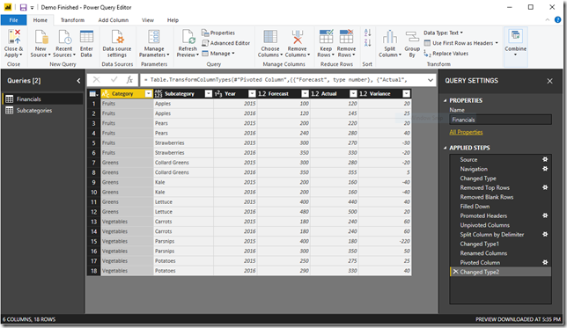](https://www.sqlgene.com/wp-content/uploads/2018/10/image.png)

Then, in DAX, you are going to take each of those outputs and combine them into a model. This consists of defining relationships between the outputted tables and adding business logic via calculated columns and measures.

[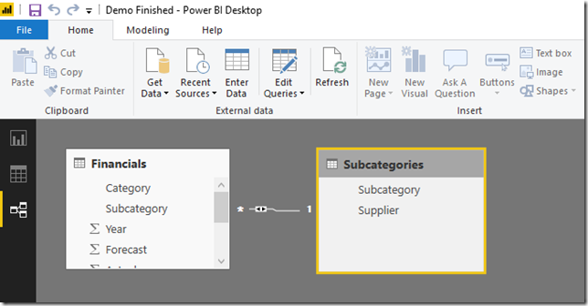](https://www.sqlgene.com/wp-content/uploads/2018/10/image-1.png)

**Reports:**

A power BI report is a series of visualizations, filters and static elements on a canvas. Power BI reports are saved as a single PBIX file and connect to a single dataset. Remember, a Power BI dataset can have many data sources.

[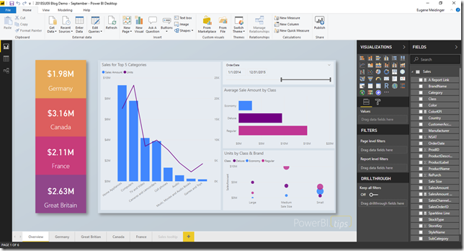](https://www.sqlgene.com/wp-content/uploads/2018/10/image-2.png)

**Dashboards:**

In Power BI, dashboards are a way of pulling together visualizations from various reports. When you think dashboard, you are probably thinking something like Microsoft’s [definition](https://docs.microsoft.com/en-us/power-bi/consumer/end-user-dashboards): “A Power BI **dashboard** is a single page, often called a canvas, that uses visualizations to tell a story. Because it is limited to one page, a well-designed dashboard contains only the most-important elements of that story.”

However, if you look at the report example above, it probably fits that definition. It is not a Power BI Dashboard. In Power BI, a dashboard is tool for pinning visuals from different reports and other sources of data.

[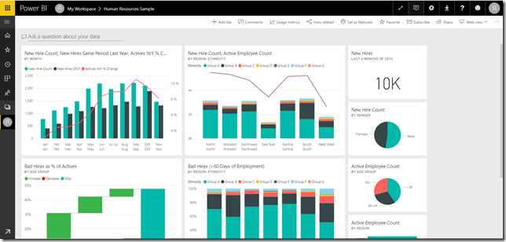](https://www.sqlgene.com/wp-content/uploads/2018/10/image-3.png)

The data sources can be saved in a report which makes it an embedded data source. Also data sources can be saved at a shared location in a report server, which then becomes a shared data source that is available to be used by multiple reports.

A dataset contains the data items you want to use from a data source. Using a query (text or using a query window), the set of fields can be selected to be included in a report. The dataset becomes shared or embedded, based on the data source selected. The dataset also includes parameters, filters and other data options.

Reports are detailed, multi-page documents that present data in various formats, including tables, charts, and graphs. They are designed for in-depth analysis and exploration.

Dashboards, on the other hand, are single-page, real-time displays that aggregate key metrics and insights from multiple reports and datasets. They are tailored for quick, at-a-glance monitoring.

1. **How reports can be created in power BI, explain two ways with Navigation of each.**

**Answer:** The first step in creating power bi reports is getting your data. There are a number of ways to import data from within your organization, file directories, and databases. You can also [copy and paste data](https://powerbi.microsoft.com/en-us/blog/quickly-create-reports-power-bi-service/) from an existing dataset. In this instance, we’ll select Samples and import a pre-configured dataset. The data is imported as-is with no editing options.

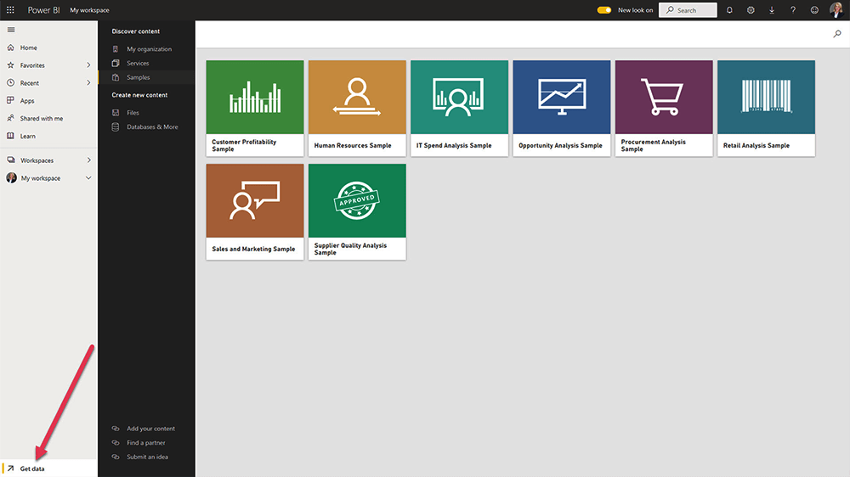

1. The dataset will appear in your workspace in Power BI Service. An easy way to start analyzing the data is to select ‘Get Quick Insights’ from the menu. A dashboard is generated whilst you work on the data. Your workspace is also where you can assign roles and permissions (Viewer, Contributor, Member and Admin)

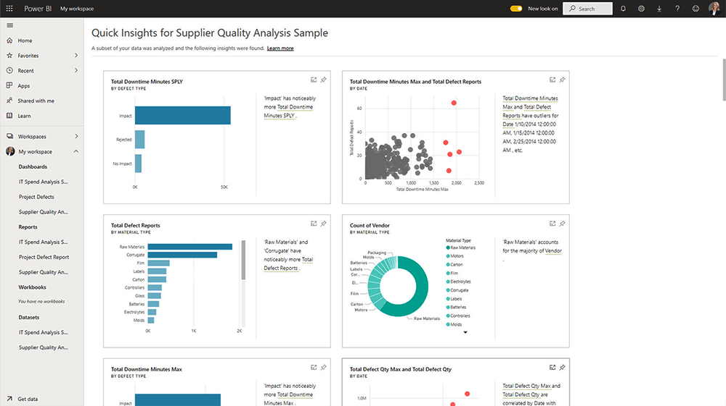

1. Next, select ‘Create Report’ to open the report builder. There are three elements in this area:

* **Canvas**. This area is blank until visuals are added
* **Visualizations pane**: Use to add and edit charts.
* **Fields pane**. A list of the fields in your dataset, based on the columns in your dataset.

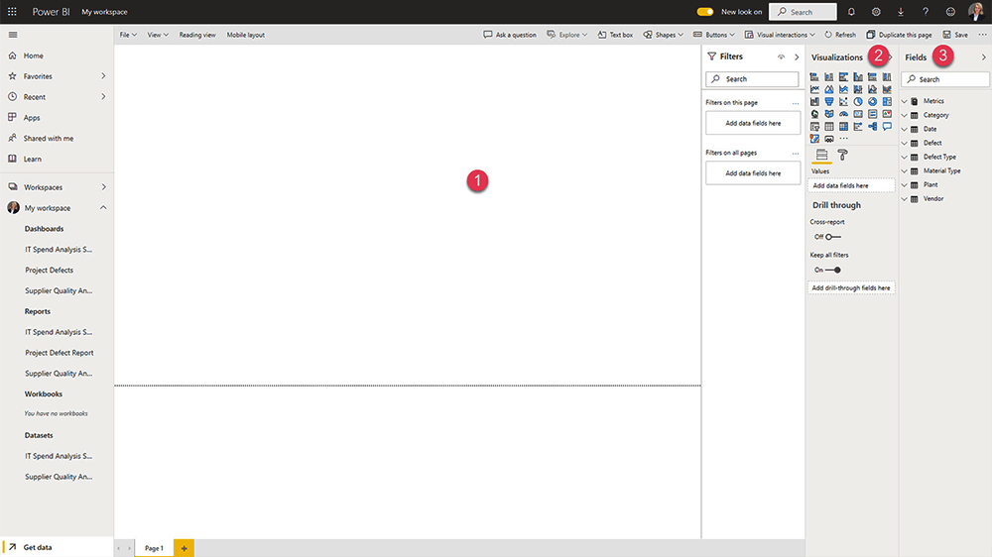

1. To start creating reports in power bi, you can either select the relevant fields from your data or pick a visualization. The visualization is displayed on the blank canvas.
2. To add a field to your report, simply click the relevant field. Power BI will automatically add the field to the right area in your chart. You can also drag and drop fields into the axis, legend, and values area.

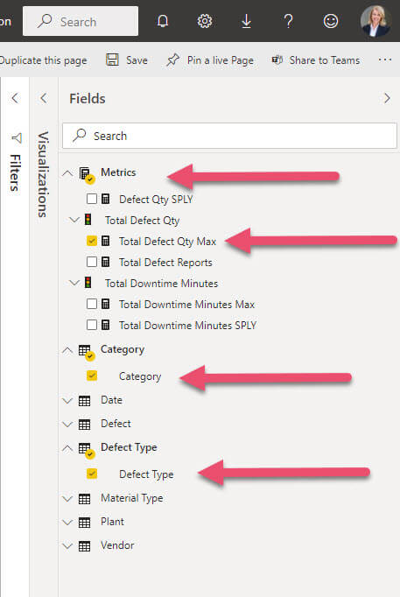

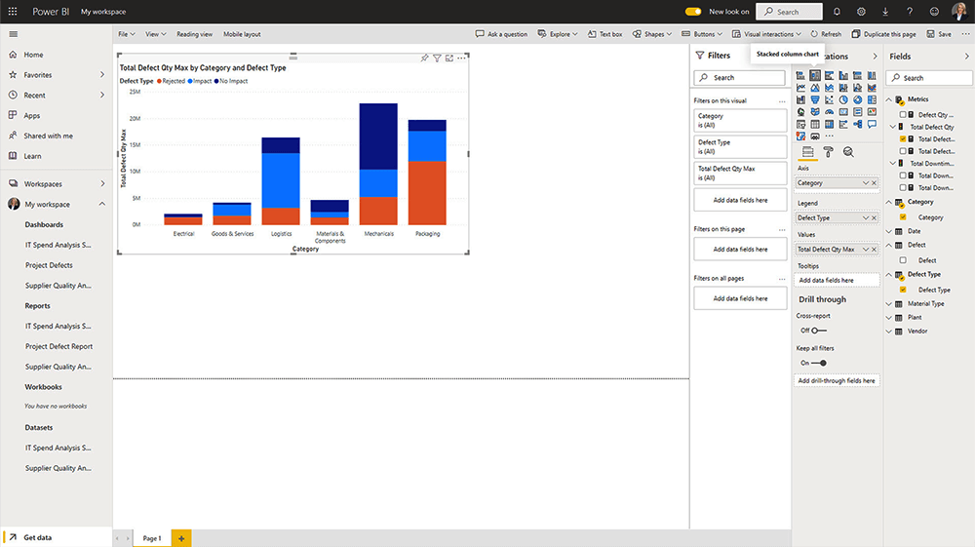

1. As you add fields, the chart will start to take shape. If needed, change the chart by selecting another option in the Visualizations pane.
2. Once you are happy with the data visualization, it’s time to format the chart. Click the ‘format’ icon to access a range of options, including the size and colors of the chart, borders, and tooltips. If you’d like to add a title or details to the report, click the ‘Text box’ option in the top menu.
3. Use the ‘Reading View’ to check how the report will appear to others.

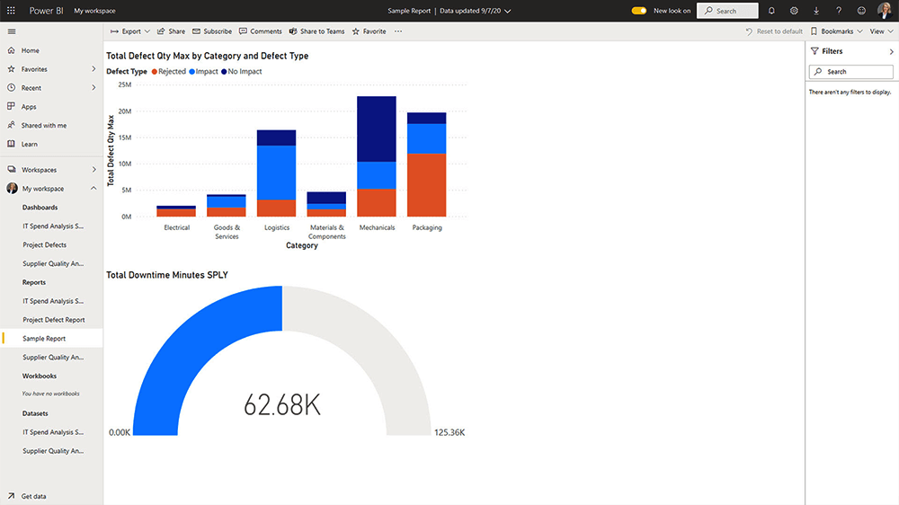

1. Add more visualizations as needed.
2. Remember to save your work.
3. Next, create a dashboard by selecting ‘Pin to a live page’. You can add the report to an existing dashboard or build a new dashboard.

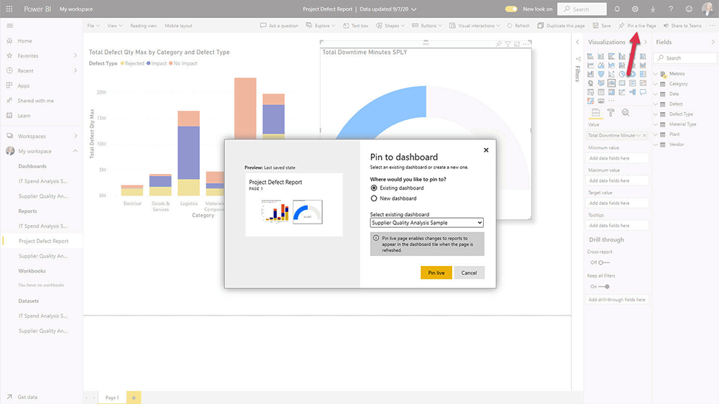

1. Dashboards offer numerous editing options, including the ability to add more tiles and different content types.
2. When you’ve finished your work, there are a few ways to use your reports under ‘File:

* Export reports to PowerPoint or as PDF
* Embed in a SharePoint site.

1. At any time, personalize your display settings using ‘View’. Change the size of the report and colors for improved readability.

That’s it – you’ve taken you first step in creating reports in Power Bi Services.

To share your report, select ‘Share’ from the top navigation, complete the form, and share it with your team. Reports and dashboards may be shared with internal and external users.

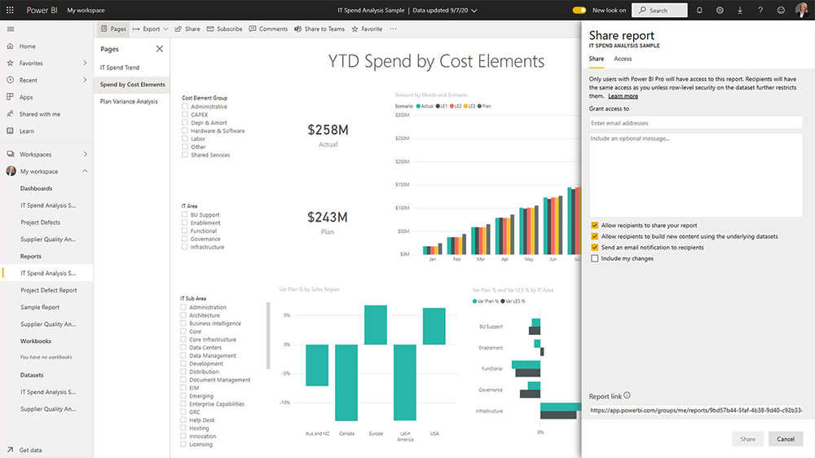

There are a few caveats to note about report sharing:

* Recipients can view and interact with the report or dashboard but can’t edit it.
* Depending on permissions, recipients can share the reports with others.
* You will need a [Power BI Pro license](https://docs.microsoft.com/en-us/power-bi/fundamentals/service-features-license-type) to share your reports. Recipients will also need a license to view the content.

1. **How to connect to data in Power BI? How to use the content pack to connect to google analytics? Mention the steps.**

**Answer:** In this quickstart, you connect to data using Power BI Desktop, which is the first step in building data models and creating reports.

[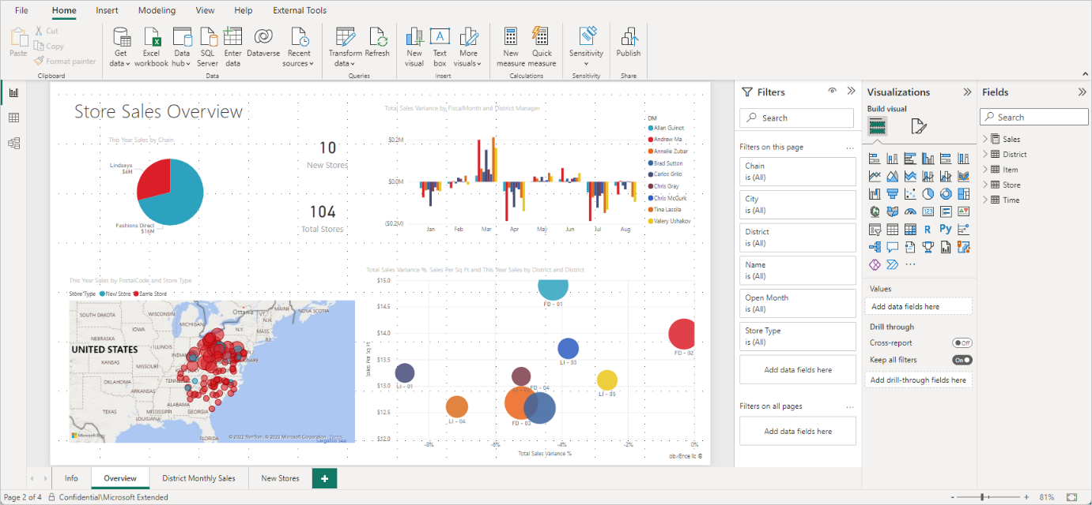](https://learn.microsoft.com/en-us/power-bi/connect-data/media/desktop-quickstart-connect-to-data/what-is-desktop_01.png#lightbox)

**Launch Power BI Desktop**

Once you install Power BI Desktop, launch the application so it's running on your local computer. You're presented with a Power BI tutorial. Follow the tutorial or close the dialog to start with a blank canvas. The canvas is where you create visuals and reports from your data.

[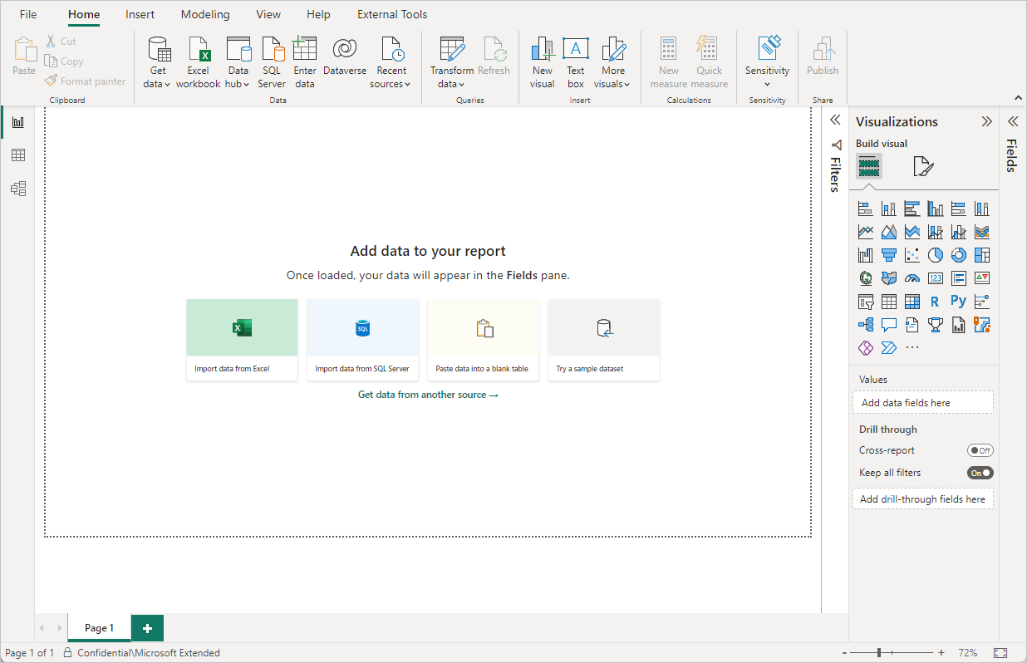](https://learn.microsoft.com/en-us/power-bi/connect-data/media/desktop-quickstart-connect-to-data/qs-connect-data_01.png#lightbox)

**Connect to data**

With Power BI Desktop, you can connect to many different types of data. These sources include basic data sources, such as a Microsoft Excel file. You can connect to online services that contain all sorts of data, such as Salesforce, Microsoft Dynamics, Azure Blob Storage, and many more.

To connect to data, from the **Home** ribbon select **Get data**.

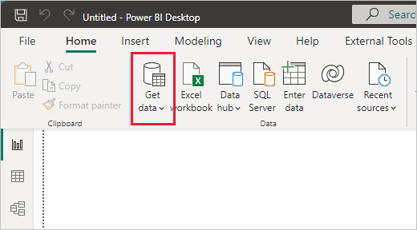

The **Get Data** window appears. You can choose from the many different data sources to which Power BI Desktop can connect. In this quickstart, use the Excel workbook that you downloaded in [Prerequisites](https://learn.microsoft.com/en-us/power-bi/connect-data/desktop-quickstart-connect-to-data#prerequisites).

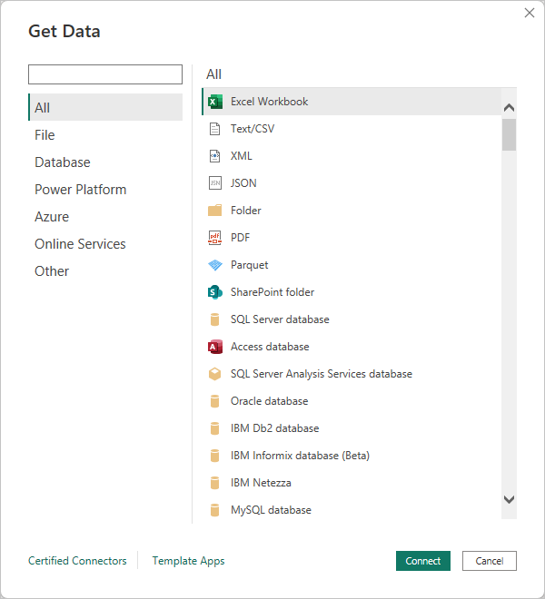

Since this data source is an Excel file, select **Excel** from the **Get Data** window, then select the **Connect** button.

Power BI prompts you to provide the location of the Excel file to which to connect. The downloaded file is called *Financial Sample*. Select that file, and then select **Open**.

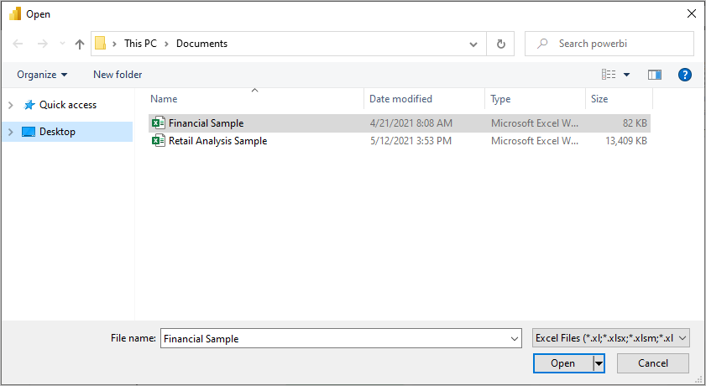

Power BI Desktop then loads the workbook and reads its contents, and shows you the available data in the file using the **Navigator** window. In that window, you can choose which data you would like to load into Power BI Desktop. Select the tables by marking the checkboxes beside each table you want to import. Import both available tables.

[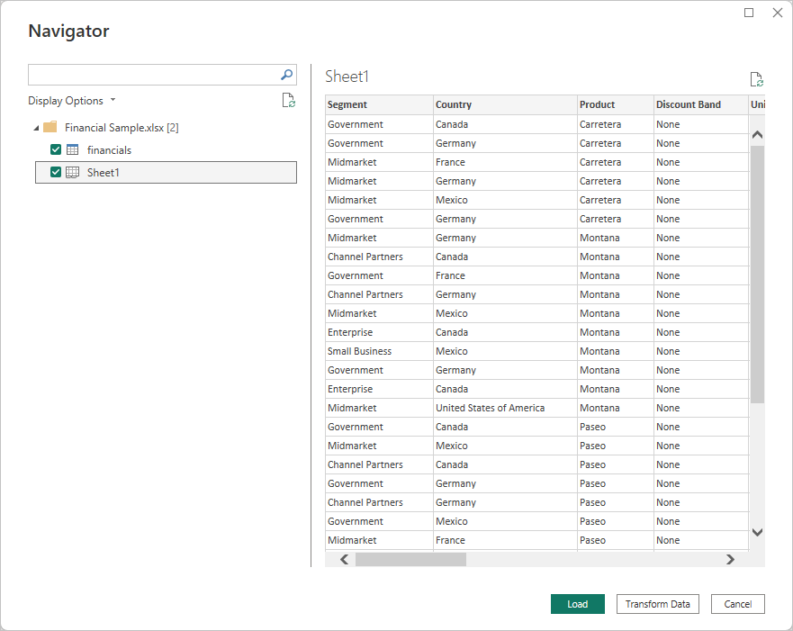](https://learn.microsoft.com/en-us/power-bi/connect-data/media/desktop-quickstart-connect-to-data/qs-connect-data_05.png#lightbox)

Once you've made your selections, select **Load** to import the data into Power BI Desktop.

**View data in the Fields pane**

Once you've loaded the tables, the **Fields** pane shows you the data. You can expand each table by selecting the arrow beside its name. In the following image, the *financials* table is expanded, showing each of its fields.

[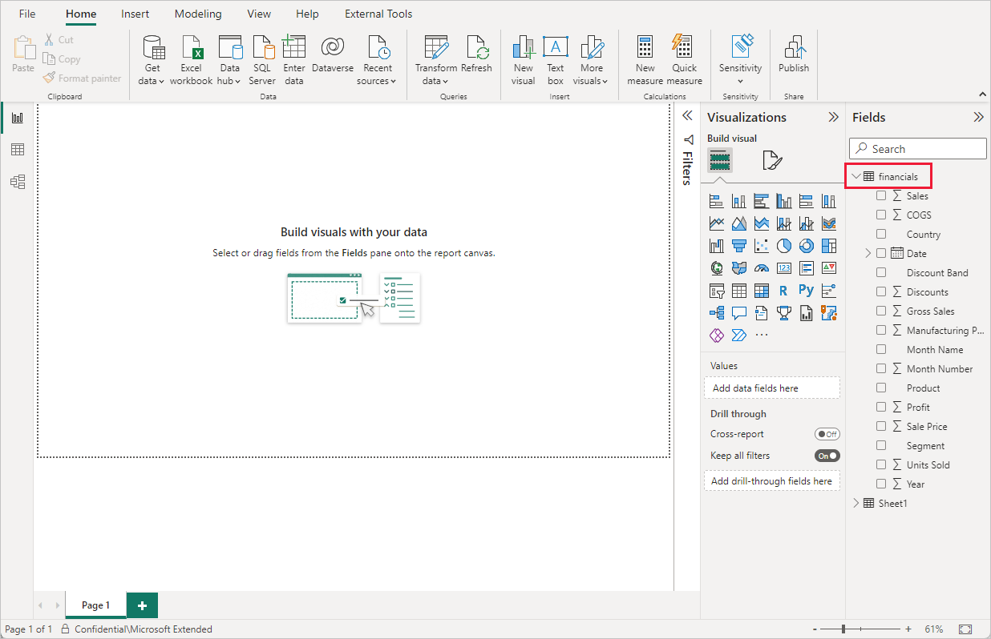](https://learn.microsoft.com/en-us/power-bi/connect-data/media/desktop-quickstart-connect-to-data/qs-connect-data_06.png#lightbox)

And that's it! You've connected to data in Power BI Desktop, loaded that data, and now you can see all the available fields within those tables.

# Connecting Power BI with Google Analytics

In Power BI, it’s straightforward to connect to the Google Analytics content pack.

1. In the left navigation pane, click Get Data.[](https://powerbicdn.azureedge.net/mediahandler/blog/legacymedia/6758.Left-Nav_5F00_Get-Data.png)
2. In the Services box, click Get.[](https://powerbicdn.azureedge.net/mediahandler/blog/legacymedia/0624.Services-_2D00_-Get.png)
3. From the menu of online services, select Google Analytics, and then click Connect.[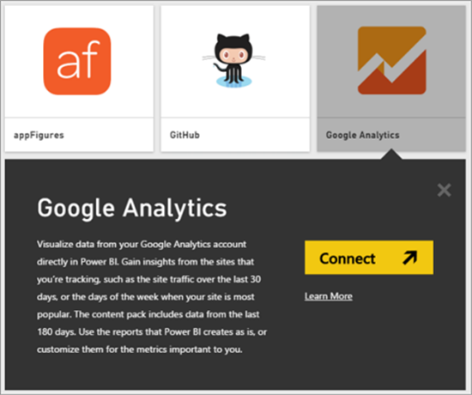](https://powerbicdn.azureedge.net/mediahandler/blog/legacymedia/8156.Google-Analytics-_2D00_-Connect.png)
4. Enter the Google Analytics account, property, and view that you want to connect to. Then sign in with your Google Analytics credentials.[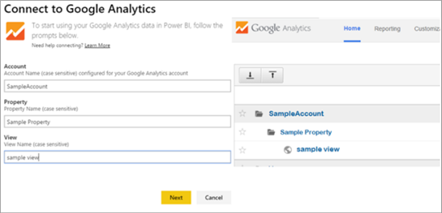](https://powerbicdn.azureedge.net/mediahandler/blog/legacymedia/6253.Connect-to-Google-Analytics.png)
5. To permit Power BI to connect to Google Analytics, click Accept.[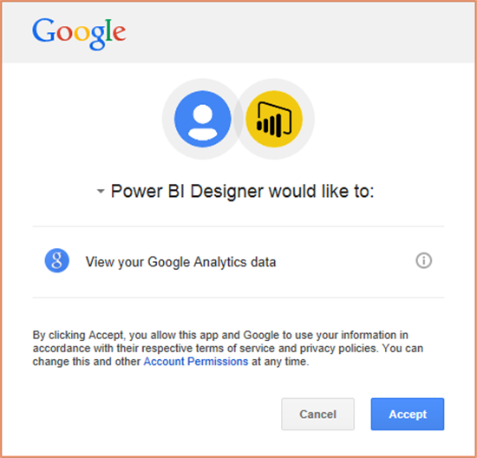](https://powerbicdn.azureedge.net/mediahandler/blog/legacymedia/5700.Permit-Power-BI-to-Connect-to-GA.PNG)
6. When the import process completes, you will see a new dashboard, report, and model in the Navigation Pane. Select the dashboard to view your imported data.[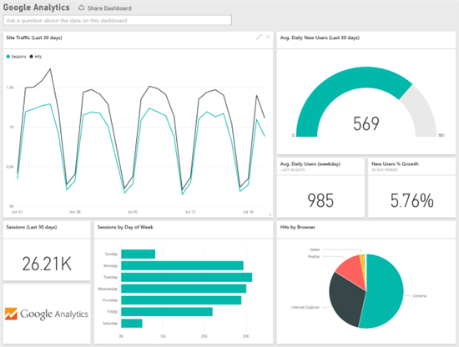](https://powerbicdn.azureedge.net/mediahandler/blog/legacymedia/2630.GA-Dashboard-Post_2D00_Import-View.png)

You can also import Google Analytics data directly into Power BI Desktop (formerly Power BI Designer).

1. Launch Power BI Desktop. On the ribbon, in the External Data group, click Get Data.[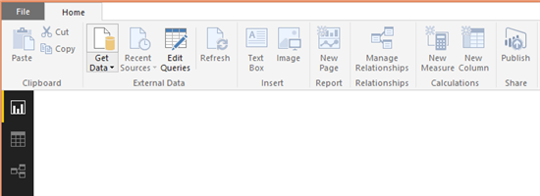](https://powerbicdn.azureedge.net/mediahandler/blog/legacymedia/7673.External-Data-_2D00_-Get-Data.PNG)
2. From the drop-down menu, click More…[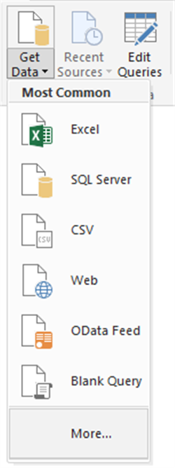](https://powerbicdn.azureedge.net/mediahandler/blog/legacymedia/3568.Get-Data-dropdown-_2D00_-More.PNG)
3. In the Get Data window, click Other. From the list of other data sources, click Google Analytics, and then click Connect.[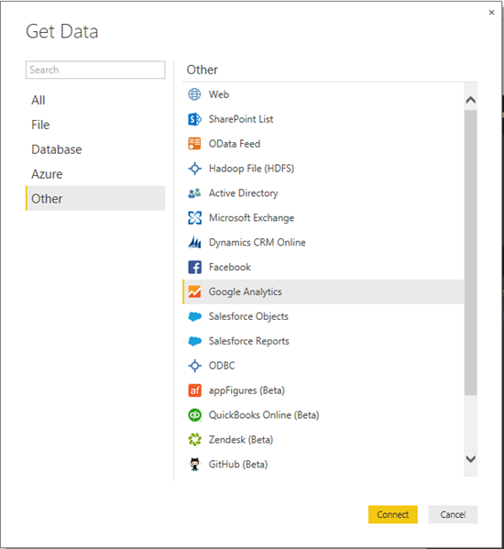](https://powerbicdn.azureedge.net/mediahandler/blog/legacymedia/8875.Get-Data-_2D00_-Other-_2D00_-GA-_2D00_-Connect.PNG)
4. Read the information about connecting to a third-party service, and then click Continue.[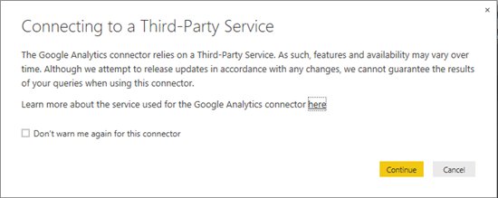](https://powerbicdn.azureedge.net/mediahandler/blog/legacymedia/6076.Connecting-to-a-Third_2D00_Party-Service.PNG)
5. Google Analytics asks Power BI Desktop for permission to connect to your data. Click Accept.[](https://powerbicdn.azureedge.net/mediahandler/blog/legacymedia/6014.Permit-Power-BI-to-Connect-to-GA.PNG)
6. Power BI Desktop shows that you’re signed in to Google Analytics. To load your Google Analytics data, click Connect.[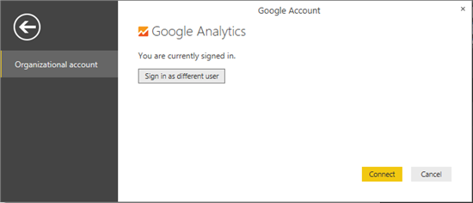](https://powerbicdn.azureedge.net/mediahandler/blog/legacymedia/4606.GA-Sign-in.png)
7. Power BI Desktop loads the Google Analytics data. Now you can start creating your amazing dynamic reports.[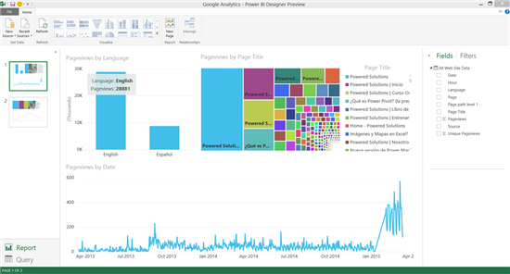](https://powerbicdn.azureedge.net/mediahandler/blog/legacymedia/0601.GA-Dashboard-Design-Preview.png)

Power BI makes it possible for anyone to connect to huge amounts of structured and unstructured data from multiple sources. By importing data from Google Analytics into the mix, organizations can view their website’s performance in the context of many other variables.

Power BI has the tools for manipulating this data, representing it visually, and sharing it easily with your colleagues. The more sources of data you have, with the right tools to analyze and visualize them, the more likely that important insights will emerge.

1. **How to import Local files in Power BI? Mention the Steps**.

**Answer:** If you want to import Analytics data manually through Power BI, follow these instructions.

1. In Power BI, click **Get Data** in the lower left screen.
2. Under **Import or Connect to Data** > **Files**, click **Get**.

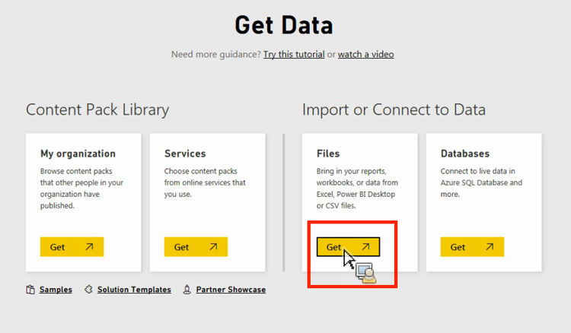

1. Click Local File.

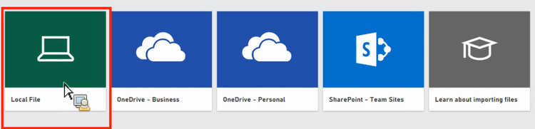

1. Choose which file to upload and click **Open**.
2. Click **Upload** under **Upload your Excel file to Power BI**.

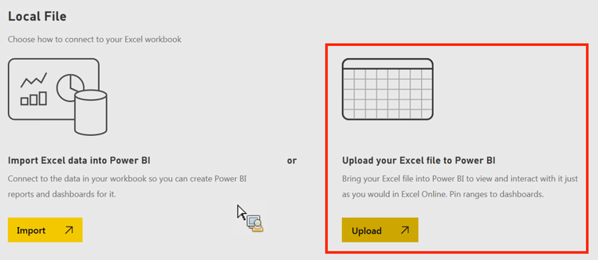

1. The message “Your file has been uploaded” should appear.
2. **In Power BI visualization, what are Reading View and Editing view?**

**Answer:** There are two modes for interacting with reports in the Power BI service: Editing view and Reading view. If you're a business user, then you're more likely to use Reading view to consume reports created by others. Editing view is used by report designers, who create the reports and share them with you. Reading view is your way to explore and interact with reports created by colleagues.

## Select Editing view and Reading view

Most reports open in Reading view. To switch from Reading view to Editing view, select **Edit** from the action bar. If **Edit** is grayed out, that means that you don't have permissions to edit the report.

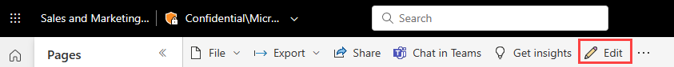

To switch back to Reading view, select **Reading view** from the action bar.

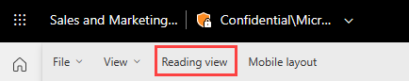

Even in Reading view, the content isn't static. You can dig in, looking for trends, insights, and other business intelligence. Slice and dice the content, and even ask it questions using your own words. Or, sit back and let your data discover interesting insights for you; send you alerts when data changes, and email reports to you on a schedule you set. All your data, anytime, in the cloud or on-premises, from any device